38.75: a) The wavelength of the gamma rays is
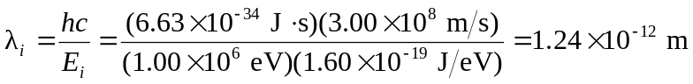
and the wavelength of the final visible photons is  So, the increase in wavelength per interaction (assuming about 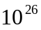 interactions) is 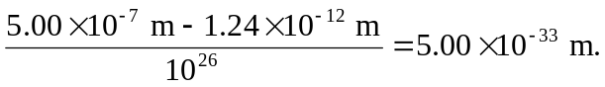
b) 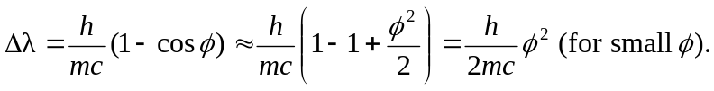
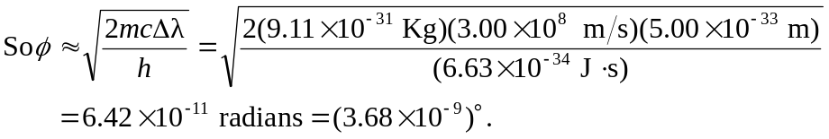
c)

How far does light travel in this time?
